BLENDER PARTICLES O.S.C

Needs:

Blender ( Last Version ): The famous free and open source 3D Package,

AddRoutes: An Addon for blender to manage OSC and Midi’s network Protocoles.

The Blend File provided with this archive

Any osc message sender you use.

Installations:

Install Blender first.
Once you have installed it, a splash screen’ll appear at first start. This screen allow you to configure the interface and the keyboard’s shortcuts. Pease choose blender 2.7x shortcuts, if you want to be able to talk the same language as me.
You’ll need to run the application during the show by keyboard shortcuts on the second screen display.

Once it’s installed, you ‘ll have to install the OSC addon addroute from blender in the user preferences window. (Ctrl+Alt+U)
follow the instructions on the web page link.

Restart blender after that to be sure that the preferences are saved.

Running the particle System:

Launch Blender and load the file provided “Particle_15mn_...blend”
This file is configured with two separated windows. One for the blender interface, and another one for the output display for your projection device.
Slide the projection device windows on the projector screen and press Alt+F11 to go full screen.
(for Mac user, you should deactivate system shortcuts or configure it for freeing the keyboard’s key)
Go back to your system display if you need to configure the scene.

The file is configurated for playing 15mn of particles animation at 25 frames per second. Once this time will be reached, blender ll loop back to the start of the particle’s animation. An OSC message is configured to go back to first frame and then reset the animation.

There is other OSC messages that ‘ll be exposed later in this document.

You’ll have to play the animation (shortcut (Alt+A) ) from the Projector Window because this file is configured to prevent the others windows to run the animation. That technique avoid frame drops, excluding other windows calculations.

We have to play the animation to let blender calculate the particles motions. (Osc message do not needs to play the animation).

You can change the the render type in the display window by pressing (Alt+Z) twice or (Shift+Z) twice.

Where to find the OSC parameters and messages?
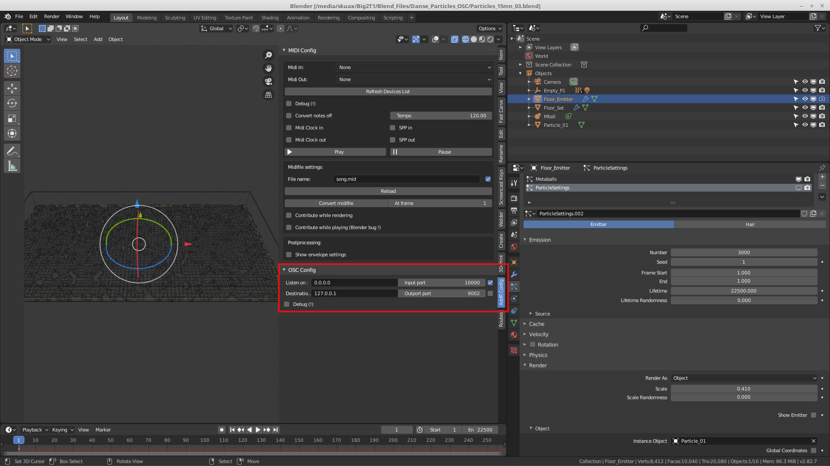

OSC Network configuration can be edited in the 3dview side pannel (shortcut (N) )
in the tab AddR Config.

The number of tabs may change regarding the number of addons installed in blender.

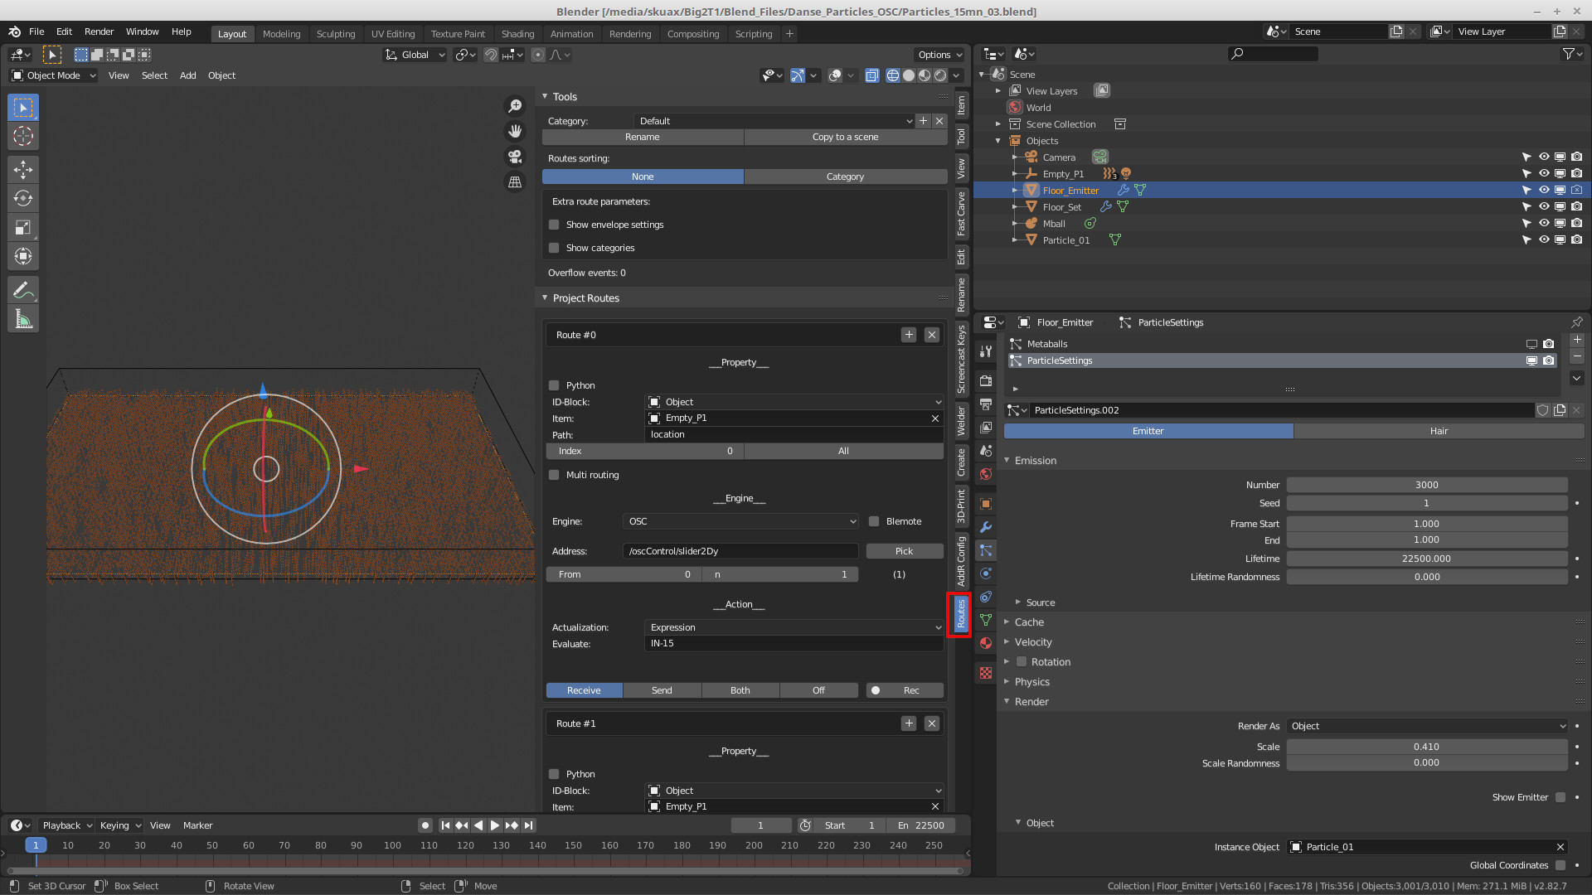
This Tab, “Routes” is used for configuring the name and actions of the OSC message.

Message format and list:

The messages are all received with this syntax: /oscControl/ and followed by the message name itself. (exemple: /oscControl/P1y)

List of Actual message and there actions on blender particles’s system:

- /oscControl/P1x: position of the performer on x ( float range(0,16))

- /oscControl/P1y: position of the performer on y ( float range(0,30))

- /oscControl/P2x: position of the performer on x ( float range(0,16))

- /oscControl/P2y: position of the performer on y ( float range(0,30))

- /oscControl/P3x: position of the performer on x ( float range(0,16))

- /oscControl/P3y: position of the performer on y ( float range(0,30))

-/oscControl/button1: play head to first frame (banger)

- /oscControl/slider1: Center Collider Zone Scale to make it smaller ( float range (0,1))

- /oscControl/slider2: Max speed for boids particles ( float range (0,5))

-//oscControl/slider3: Min speed for boids Particles(percent of the previous value ( float range (0,1))

-//oscControl/slider4: Ability for the boids to execute fast turns ( float range (0,1))

-//oscControl/slider5: Particle Color on HSV. Hue ( float range (0,1))

-//oscControl/slider6: Particle Saturation on HSV. Saturation ( float range (0,1))

-//oscControl/slider7: Particle Value on HSV. Value ( float range (0,1))

-//oscControl/tiltX: Camera Tilt on X. Value ( float range (-1,1)) initial state must be 0

-//oscControl/tiltY: Camera Tilt on Y. Value ( float range (-1,1)) initial state must be 0

-//oscControl/zoom: Camera position on Z. Value ( float range (-1,1)) initial state must be 0

-//oscControl/border: Display green border. Value ( bool (0/1))

-//oscControl/players: Display players positions red=P1 yellow=P2 Purple=P3. Value ( bool (0/1))

Notes

P1 is the boid system (pray/predator) target and the particles try to reach it regarding there velocity and ability to turn.

P2/P3 and center zone are coliders that block the boids particles. More boids are touching the colliders more blender have to execute calculation. It may result some framerate drop with too much boids. To avoid that, you can reduce there ability to turn fast with a high velocity so the will drift a lot before coming back to there goal.

